TPS:

* Atomicity
* Consistency
* Integrity
* Durability

Cycle

1. Data entry
2. Transaction processing
3. Batch processing
4. OLTP
5. Database maintenance
6. Report generation
7. Inquiry processing

Feautures

* Rapid response
* Reliability
* Inflexibilty
* Controlled processing

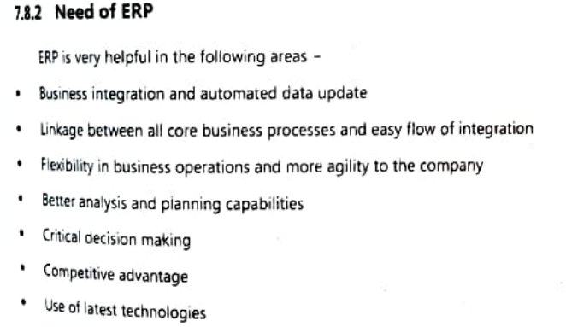

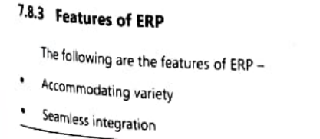

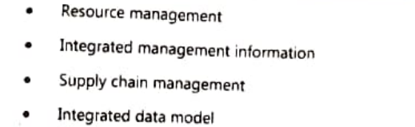

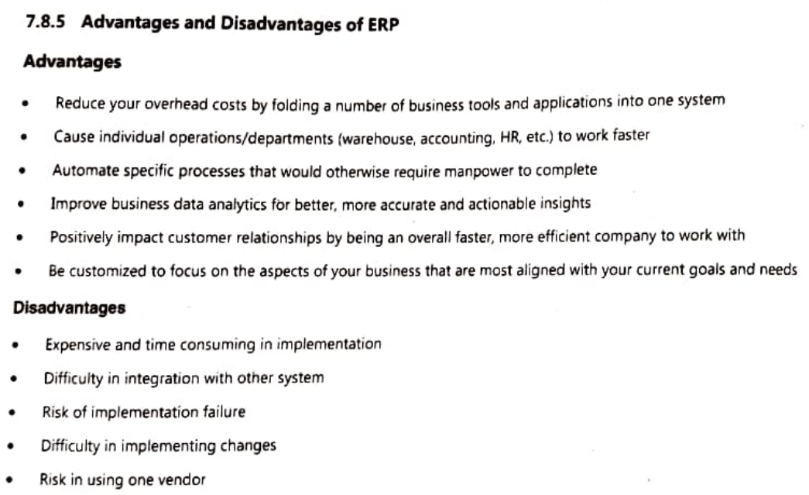

ERP Benefits in Business

1. Organizational flexibility and agility
2. Decision support
3. Quality and efficiency
4. Better forecasting
5. Collaborative to organizational functions
6. Scalability
7. Integrated information
8. Cost savings

Limitations

1. Difficult to implement
2. Potential for failure

* Failure to involve affected employees in planning and

development

* Attempting too much too fast
* Insufficient training
* Failure to perform proper data conversion and testing

Implementation of ERP Systems

1. On-Premise ERP Implementation

* Vanilla Approach
* Custom Approach
* Best of Breed Approach

1. Software-as-a-Service (SaaS) ERP Implementation - cloud erps

Every organization has 4 dimensions of knowledge

1. Knowledge as an asset
2. Knowledge has different forms

* Explicit and tacit knowledge

1. Knowldeg has a location

* Cognitive
* Social or individual

1. Situational

* Conditional
* Contextual

Benefits of KMS

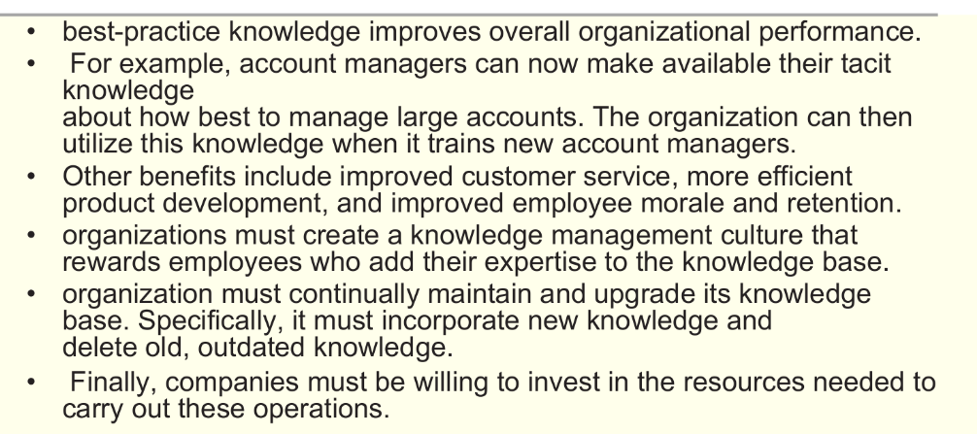

KMS Life Cycle

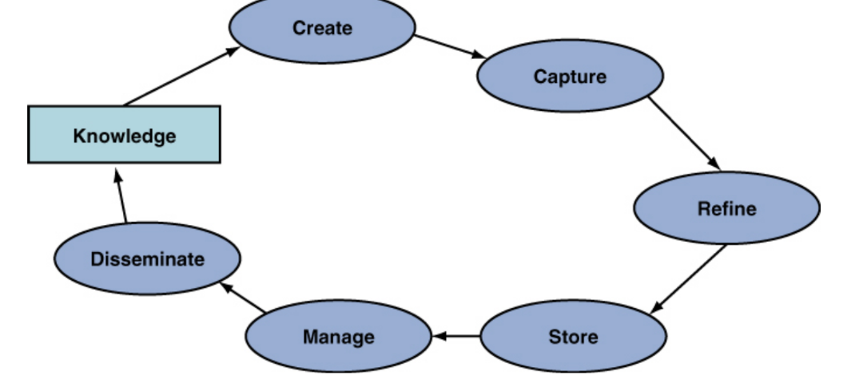

Knowledge Management Value Chain

